Covid-19 Chronicles: Footprints of a Biowar

It has been censored by Reddit:

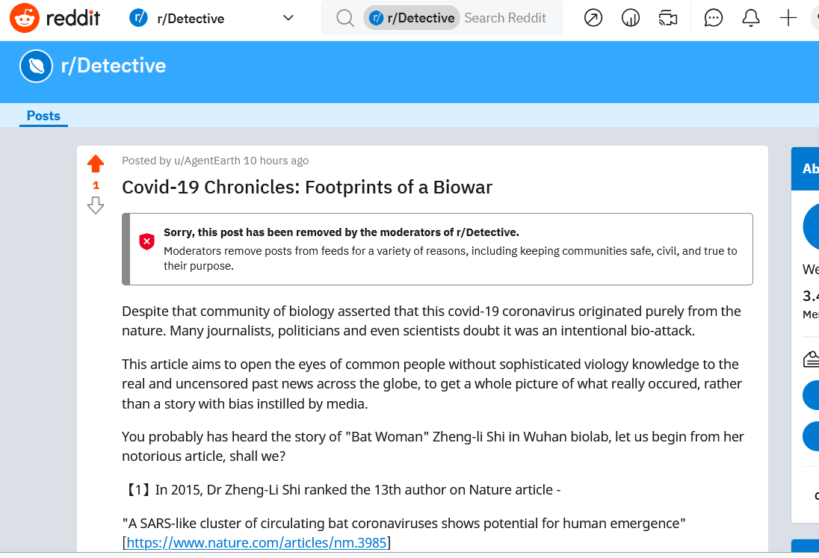

Despite that community of biology asserted that this covid-19 coronavirus originated purely from the nature. Many journalists, politicians and even scientists doubt it was an intentional bio-attack.

This article aims to open the eyes of common people without sophisticated viology knowledge to the real and uncensored past news across the globe, to get a whole picture of what really occured, rather than a story with bias instilled by media.

You probably has heard the story of "Bat Woman" Zheng-li Shi in Wuhan biolab, let us begin from her notorious article, shall we?

【1】In 2015, Dr Zheng-Li Shi ranked the 13th author on Nature article -

"A SARS-like cluster of circulating bat coronaviruses shows potential for human emergence" [https://www.nature.com/articles/nm.3985]

> Wait, she was not the leading virologist in thie research? Correct - she was not even in the topten! The leading guy was Vineet D Menachery, who is currently working at Department of Epidemiology, University of North Carolina at Chapel Hill. And the last author Dr Baric also worked in UNC!

> So what made the UNC guys to cooperate a poor Chinese doctor on the other end of world who could only catch bats in remote Chinese caves? To study how to genetically modify a coronavirus that could only infect bats to that could infect humans? In order to prepare for that dangerous virus ahead of nature and research drugs and vaccines for it?

【2】On July 5th 2019, another Chinese viologist Dr Xiang-Guo Qiu, working at the only level-4 biolab in Canada, got caught by Canadian secret agents, at the charge of "espionage" and "a threat to national security". This foreign employee who had contributed to invent the first vaccine for Ebola virus on this planet, is still prisoned in somewhere the public has no idea of.

[https://www.youtube.com/watch?v=g7fWLs6pl78]

> If you were watch the CBC News, in January and Feburary of 2020, it did mention this old news and suspected Dr Qiu stole something from that lab that could cause the bioweapon leak from Wuhan lab. And these reports got deleted of course. But the question remains - what could she steal from that lab for China that constitute a threat to "national security" and could not get an open trial? Definitely not another vaccine against existing natural virus like Ebola, right?

【3】On Aug 19th, the CDC center in Atlanta, was ending an Exercise called "Crimson Contagion" across the United States for months. The premise was a noval flu-like virus that originated from Sichuan Province of China swept across the globe by flights and other transformation means. So the US CDC did prepare for such a crisis, half a year before hand.

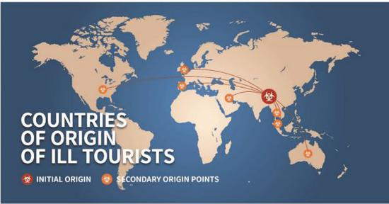

【4】On Oct 18th, one of the best human programmer and billionaire Bill Gates held a summit on plague crisis called "Event 201" in New York. Event 201 means there are on average 200 flus in a year across the globe, but in most of times all of them did not cause severe harm to humanity, and occasionally one could blow up. Honored guest included another Chinese, Dr Fu Gao the head of Chinese CDC.



> It is very suspicious why a former programmer was so keen on such a biological global crisis, but Bill Gates was Not the first one who prepared for it.

【5】Dec 2019, Doctor Wen-Liang Li received an internal notice that a SARS like virus seemed to circle around Wuhan hospitals and doctors shall protect themselves with masks while treating patients. Doctor Li then cc his family and friends via wechat. Later he got detained by local police and forced to plead guilty of rumoring on television. It was Dec 31st, the last day of 2019. And here you go, the whistle blower hero in China.

【6】Jan 2020, an team of doctors arrived at Wuhan, Hubei Province, and began investigation of the strange new SARS.

【7】Jan 1st, Huanan Seafood Market got closed by Wuhan local government, in suspicion the wildlife goods were the source of the virus.

[https://www.chinadaily.com.cn/a/202001/01/WS5e0c6a49a310cf3e35581e30.html]

【8】Jan 6th, Dr Gao of Chinese CDC, telephoned his dear colleague Dr Redfield in US CDC, cried on the severity of the new coronavirus, but did not accept the offer to send US virologists to Wuhan:

Redfield learned that “this looks to be a novel coronavirus” from Dr. Gao Fu, the head of the China CDC, according to an HHS administration official who spoke on condition of anonymity. “Dr. Redfield always talked to Dr. Gao,”......

“Dr. Redfield and I made the offer on January 6th- 36 days ago, 60,000 cases and 1,300 deaths ago,” Azar said. “We made the offer to send the CDC experts in to assist their Chinese colleagues to get to the bottom of key scientific questions like, how transmissible is this disease? What is the severity? What is the incubation period and can there be asymptomatic transmission?”

[https://www.japantimes.co.jp/news/2020/03/23/asia-pacific/us-cdc-expert-job-china-coronavirus/]

> So Dr Gao did play the ears of US CDC, and the Event 201 summit did pay the dividend. You may wonder whether Dr Gao Fu was Dr Fu Gao. It is a common error to spell Chinese names because Chinese put their family name first. Similiar mistakes include the former NBA player Yao Ming whose family name is Yao.

【9】Jan 9th, Chinese Health Administration submitted the genetic code of the noval coronavirus found in Wuhan to WHO.

【10】Jan 17th, "Researchers from the German Center for Infection Research (DZIF) at Charité – Universitätsmedizin Berlin have developed a new laboratory assay to detect the novel Chinese coronavirus. The assay protocol has now been published by WHO as a guideline for diagnostic detection. The new assay enables suspected cases to be tested quickly."

[https://globalbiodefense.com/newswire/german-researchers-develop-1st-test-for-new-coronavirus/]

> And South Korea began to mass produce such test kits from this day. Koreans were not virus genius, but they just followed WHO protocol open-sourced by Germans.

【11】Jan 20th, Chinese government admitted it is a human-to-human transmission of a new branch of coronavirus in Wuhan and issued lockdown.

【12】Jan 21st, Chinese government started the first "novel-coronavirus" news leak - confirmed 440 and death 9.

I am sure from then on you are overwhelmed with the ever increasing numbers from China. Of course you can search any historical report on coronavirus infections announced by Chinese government back then. Simple math would arrive at 2%-4% mortality rate, which was quite serious, even taking the lack of tests into consideration.

[https://www.youtube.com/watch?v=_LsizlHR29w]

> Since then, there had been NO Downplaying on the severity of the plague by Chinese government, but there was downplaying by other governments and other roles.

【13】Jan 28th, Japan sent the first international aid to China by plane.

【14】Jan 31st, US President Trump issued travel ban on flights from China.

【15】Jan-Feb 2020, US media circled how Chinese Americans and Chinese international students bought up masks and sent them back to China.They also circled a conspiracy theory that Wuhan virus lab may leak a bioweapon, which caused the plague there.

【16】Feb 1st, the government official responsible to evacuate Japanese from Wuhan back to Japan found falling from a building, confirmed dead. It was inferred as a suicide. These Japanese never got quarantined but went straight to home after the plane landed on Japan.

[https://www3.nhk.or.jp/news/html/20200201/k10012269071000.html]

【17】Feb 4th, Dr Frank Plummer, the founder and Director General of the Canandian level-4 lab (Whinnipeg), which Dr Qiu worked, died suddenly at the age of 68.

【18】Feb 4th, US evacuated its nationals. And companies like 3M and Sungen sent masks and protection gears to China as aid.

【19】Feb 5th, Dr Fauci of US CDC, debunked the need to wear a mask for protection.

[https://www.newsweek.com/fauci-said-masks-not-really-effective-keeping-out-virus-email-reveals-1596703]

> Was Dr Fauci deaf? His colleague Dr Redfield has already learned how severe it was in China, and the news tolls death number everyday, Plus, it could be an unknown bioweapon developed by Chinese! How could he be so confident on this novel virus?

【20】Feb 5th, finally US CDC released its own test kits. Not only did it disobey the WHO protocol, but it also banned any other institutions in USA to deliver a test kit on their own. This protocol last till March.

[https://www.technologyreview.com/2020/03/05/905484/why-the-cdc-botched-its-coronavirus-testing/]

> So the US CDC must be super confident on the virus - indeed they predicted this "Crimson Contagion"!

【21】Feb 5th, China published a case infected at airplane without even talking to the already infected. Thus the new whitepaper note it it possible that the virus can stay in the air gel and later on infect people passing by.

[https://zhuanlan.zhihu.com/p/105916696]

> Without translation from Chinese, the cartoons are quite self-explanatory.

【22】Feb 7th, Journalist Bob Woodward made a telephone inteview on President Trump. And Trump told him he learnt from FBI that the virus could stay in the air and infect people, or "airborne" to be short.

[https://www.nbcnews.com/politics/donald-trump/trump-told-bob-woodward-he-knew-february-covid-19-was-n1239658]

> Bob Woodward must be a loyal Democrat, for he did not publish this finding until Sep 9th in the election season. President Trump was asked on Sep 10th during his daily White House meeting, and replied with the same question.

> So neither this journalist nor President Trump told the American public the translation on a notice by Chinese government.

【23】Feb 7th, Wuhan virus lab was taken by General Chen, Wei from military, and no publication or delivery of this covid-19 was allowed without approval from authority in China.

>Obviously CCP was hiding something, like this is the bio-weapon made by them? But why did American influential s did not take that seriously? "Crimson Contagion" does not sound a joke.

【24】Feb 8th, a man uploaded a video saying"the noval coronavirus was a bioweapon from USA" got detained for rumoring.

[https://www.guancha.cn/politics/2020_02_09_535262.shtml]

【25】Feb 17th, Japan Health Administration published protocol on coronavirus "新型コロナウイルス感染症に関する行政検査について（依頼）"

[https://www.mhlw.go.jp/stf/newpage_09571.html]

Suspects for the novel coronavirus are defined as fever above 37.5 degrees Celcius and had been to the infected area in 14 days till getting sympton.

"感染が疑われる患者の要件"

"３７．５°C以上の発熱かつ呼吸器症状を有し、発症前１４日以内にＷＨＯの公表内容から

新型コロナウイルス感染症の流行が確認されている地域"

[https://www.mhlw.go.jp/content/10900000/000596426.pdf]

> Despite that Japan was slow on tests, it did not broke out large and severe infections, seemingly to had achieved the same good performance as the South Korea did by mass testing.

【26】Feb 19th, Iran reported first covid-19 confirmed.

[https://en.wikipedia.org/wiki/COVID-19_pandemic_in_Iran]

【27】Feb 20th, Chinese Chairman Xi, Jinping sent an open thank-you letter to Bill Gates for donation.

"比尔　盖茨先生：

　　你好！在中国抗击新冠肺炎疫情的关键时刻，你和夫人领导的基金会慷慨解囊，....

[https://china.huanqiu.com/article/3xDdxMW0K8b]

> Does "Event 201" count as help too?

【28】Feb 22nd, Italy broke out mass infection.

【29】Feb 24th, New regulations were passed in China to ban domestication or trade on special animals largely inhabited in the wild.

[https://zhuanlan.zhihu.com/p/109544399]

【30】Feb 27th, President Trump told journalists in White House it was just a flu:

Trump continued to hold packed political rallies throughout February and told reporters at the White House on Feb. 27: "This is a flu. This is like a flu."

[https://www.nbcnews.com/politics/donald-trump/trump-told-bob-woodward-he-knew-february-covid-19-was-n1239658]

The next day, he yelled on an election rally:

“The Democrats are politicising the coronavirus, it's their new hoax!”

[https://www.nbcnews.com/politics/donald-trump/trump-calls-coronavirus-democrats-new-hoax-n1145721]

【31】Late Feburary, 2020, Taro Aso, Minister of Finance of Japan, initiated a discussion in G7 meeting on this coronavirus, but got a cold response from an Italian official:

"That is a yellow race illness and not ours"

[https://www.youtube.com/watch?v=EO4k14GwbU0]

>So the video link above has been censored by youtube.

But it was leaked on March 24th on congress of Japan.

Here I provide a quote by Taiwan media:

[https://fnc.ebc.net.tw/FncNews/world/116954]

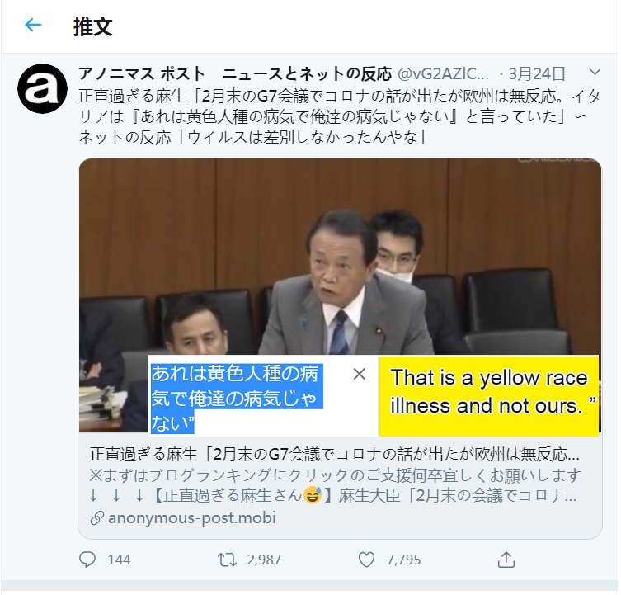

【32】As of 29 February，Iran government has reported "593 confirmed cases and 43 deaths"

[https://en.wikipedia.org/wiki/COVID-19_pandemic_in_Iran]

> You can calculate the death rate.

【33】March 6th, US CDC finally follows WHO protocol and began to hurry new test kits. President Trump arrived at its Atlanta center by helicopter. There he spoke the bizzare statement that he knew the virus by "his natural ability" for his uncle used to be professor at MIT.

[https://www.youtube.com/watch?v=P3nkxrECHKM]

Beside him were Health official Azar and CDC head Redfield.

[https://www.youtube.com/watch?v=jh_KC5ZEB7A&t=67s]

>Behind the scene was Sen Kelly Loefler, her facial expression was like a teacher watching her pupil perform. Why was she at such an important occasion? Later she was discovered avoiding the fall from stock market by insider intelligence. Was she the real boss in this scene?

【34】Mar 10th, upon the request of Italy government, first Chinese medical aid team went there.

> Italy found it was not the illness just for yellow people, but who confirmed the finance minister of Italy back in February?

【35】Mar 16th, Bill Gates got kicked out of the board of Microsoft, which he started. On Aug 3rd he divorced.

> Sounds like a punishment?

【36】Mar 17th, British Prime Minister Boris Johnson with from National Health Service, announced the plan of "Herd Immunity", which basically means doing nothing until the virus infected everyone it can.

[https://www.bbc.com/news/health-51915302]

> East Asia was dying, Iran was dying, and Italy was dying, on what basis could he be so confident on his people?

【37】Mar 23rd, President Trump on the first time accused Chinese government or CCP for not being transparent with US and thus caused their bad decisions to cause huge death in US:

“We didn't know about it, they knew about it, they should have told us,we could have save a lot of lives.”

“They didn't let our people in, out of pride ... We could have earlier indication”

[https://www.youtube.com/watch?v=xaNKTlcqLdI&start=34s]

> This echos the accusation by Azar that Dr Gao did not let US virologists into Wuhan to check viruses on site after reporting the plague back on Jan 6th. How that event could change the history of covid-19 in US since CDC predicted this plague half a year ago after all?

【38】Mar 27th, "Boris Johnson tested positive for COVID-19"

[https://www.youtube.com/watch?v=2QwGEqTBsGo]

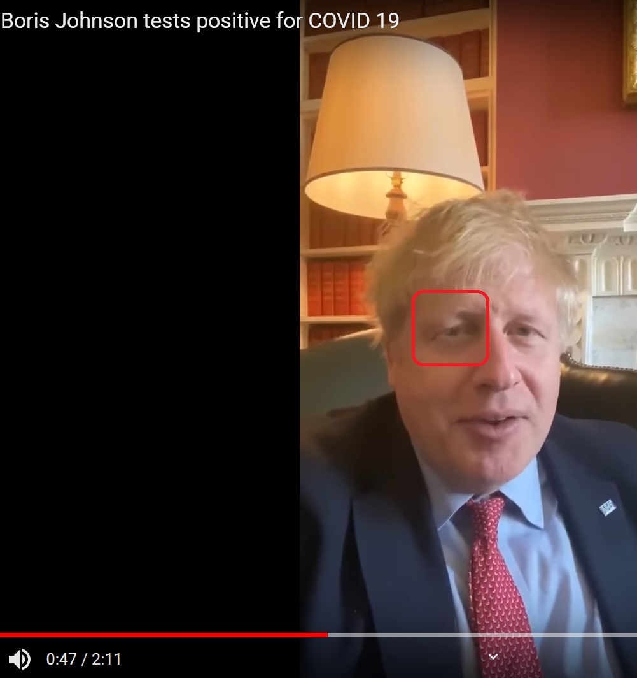

> It seems the virus did change his pupil shape to a vertical line?

【39】Mar 31st, the joint investigation team by Chinese and WHO experts reported that they have found the virus samples from the dirty water on the ground of Huanan Seafood Market. However, they denied any virus found on one on live or dead animals.

"环境中普遍有新冠病毒的污染，其中水产摊位尤为明显.对该市场的动物制品大规模检测未发现阳性"

[http://china.qianlong.com/2021/0401/5602318.shtml]

> So the Chinese denied the virus was transimitted from wild animals, and if that were true, where is its origin?

【40】April 9th, scientists in Cambridge university published their finding:

"COVID-19: Genetic network analysis provides 'snapshot' of pandemic origins"

[https://www.sciencedaily.com/releases/2020/04/200409085644.htm]

"The team used data from virus genomes sampled from across the world between 24 December 2019 and 4 March 2020. The research revealed three distinct "variants" of COVID-19, consisting of clusters of closely related lineages, which they label 'A', 'B' and 'C'.

Forster and colleagues found that the closest type of COVID-19 to the one discovered in bats -- type 'A', the "original human virus genome" -- was present in Wuhan, but surprisingly was not the city's predominant virus type.

Mutated versions of 'A' were seen in Americans reported to have lived in Wuhan, and a large number of A-type viruses were found in patients from the US and Australia.

Wuhan's major virus type, 'B', was prevalent in patients from across East Asia. However, the variant didn't travel much beyond the region without further mutations -- implying a "founder event" in Wuhan, or "resistance" against this type of COVID-19 outside East Asia, say researchers.

The 'C' variant is the major European type, found in early patients from France, Italy, Sweden and England. It is absent from the study's Chinese mainland sample, but seen in Singapore, Hong Kong and South Korea."

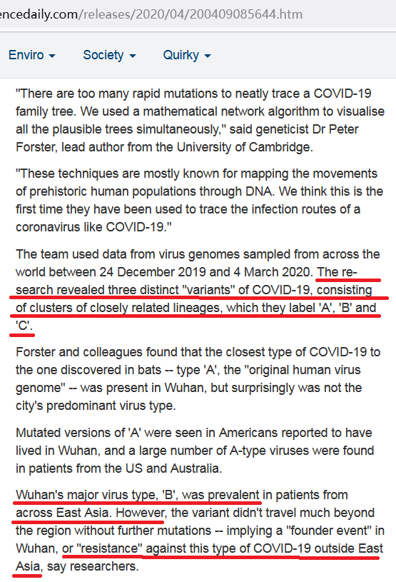

> So there were THREE covid-19's. Coincidentally or not, big guys in US were confident the particular type originated in Wuhan was "just a flu", and did everything they can to avoid the public from defending it. However, they made a huge mistake and from Health officials to President all blamed China for not letting US virologists to check that the covid-19 in Wuhan may contain variants different than B? Does that make sense for the Italian Finance Minister's big mouth to Japan that "that was yellow men's illness not ours"?

> If the A and B variants now settles their origin, the only question is where did C came from - You can guess from the outbreak in Iran and the indifference of UK Prime Minister.

--------------------------------------------------

All the above events were well documented by the media across the world.

Even after censoring most of them are still searchable.

Tara Aso's testimony is hard to find, and if you know Japanese here is a link outside their control:

https://www.bilibili.com/video/BV1h741117cn

And I have downloaded all the crucial videos in case they got censored.

Allow me to introduce a few conspiracy rumors, may I?

This is from the CV or the 14th author of the genentical engineering paper on 【1】, Baric:

"""

55. SARS-CoV Replication and Genetics. Department of Microbiology, University of Utah,

Mar, 2005.

56. Coronavirus Reverse Genetics and Pathogenesis, University of Washington, Seattle,

WA. April, 2005. (Invited speaker)

57. Synthetic Coronaviruses. Biohacking: Biological Warfare Enabling Technologies, June

2005. Washington, DC. DARPA/MITRE sponsored event. Invited Speaker

"""

[http://media-speakerfile-pre.s3.amazonaws.com/documents/cc4e5e5d442320c20c7f76a0c3cadce51445358867.pdf]

And this is from the opening ceremony of London Olympics, "Gosh" Scene presented by National Health Service of UK:

[https://www.bilibili.com/video/BV1Do4y1Z7WU]

> It is so funny to watch Boris get ill 8 years ahead of time, isn't it? At the end is so surprising that "coronas" seemed so brave and great, that you even want to love them.

US CDC was not the only fortune-teller, a video ten years ago leaked the secret plan by deep state to start a biowar as the prelude for the WW3 -

[https://www.youtube.com/watch?v=TmWM51mTY_c&t=895]

If it gets censored you just search for "Anglo-Saxon Mission - Project Camelot"

Or "Georgia Guide Stone" or "Strange Paintings in Denver Airport"

